**Excel Assignment – 6**

1. What are the various elements of the Excel interface? Describe how they’re used.

The Excel interface consist of various element that help you navigate, enter data, perform calculations and format your spreadsheet. Here are the main elements of the Excel interface and how they are used:

* Ribbon:   
  The Ribbon is the tabbed toolbar at the top of the Excel window. It contains multiple tabs, each with a set of related commands. The tabs include Home, Insert, Page Layout, Formulas, Data, Review, and View. Each tab is organized into groups, and you can access various functions and features through the Ribbon.
* Quick Access Toolbar:

Located above the Ribbon, the Quick Access Toolbar provides quick access to frequently used commands. You can customize this toolbar by adding or removing commands to suit your preferences.

* Worksheet Area:

The main area of the Excel window is the worksheet area, where you enter and manipulate data. The worksheet is a grid of cells organized into columns and rows. Each cell can contain text, numbers, or formulas.

* Columns and Rows:

Columns are identified by letters (A, B, C, etc.), and rows are identified by numbers (1, 2, 3, etc.). The intersection of a column and a row is called a cell, and each cell has a unique address (e.g., A1, B2).

* Cell:

A cell is the basic unit in Excel. You can enter data, formulas, or functions into cells. The content of a cell can be text, numbers, dates, or formulas.

* Name Box:

Located to the left of the Formula Bar, the Name Box displays the address or name of the selected cell. You can use it to navigate quickly to different cells in the worksheet.

* Formula Bar:

The Formula Bar is located above the worksheet and displays the contents of the selected cell. You can enter or edit data, formulas, or functions directly in the Formula Bar.

* Sheet Tabs:

At the bottom of the Excel window, you'll find sheet tabs that allow you to switch between different sheets in a workbook. You can add, delete, or rename sheets as needed.

* Status Bar:

The Status Bar is located at the bottom of the Excel window and provides information about the current status of the worksheet, such as the sum of selected cells, average, count, and more.

* Zoom Slider:

The Zoom Slider is located at the bottom right corner of the Excel window. It allows you to zoom in or out to adjust the view of the worksheet.

* View Options:

You can find various view options in the View tab on the Ribbon. These include Normal view, Page Layout view, and Page Break Preview, each providing a different perspective on your data.

1. Write down the various applications of Excel in the industry.

The various application of Excel in the industry are:

* Business Analysis
* People Management
* Managing operations
* Performance Reporting
* Office Administration
* Strategic Analysis
* Project Management
* Managing Programs
* Contract Administration
* Account Management

1. On the ribbon, make a new tab. Add some different groups, insert

Insert commands in the groups and name them according to their commands added. Copy and paste the screenshot of the steps you followed.

Go to file->options->Customize Ribbon

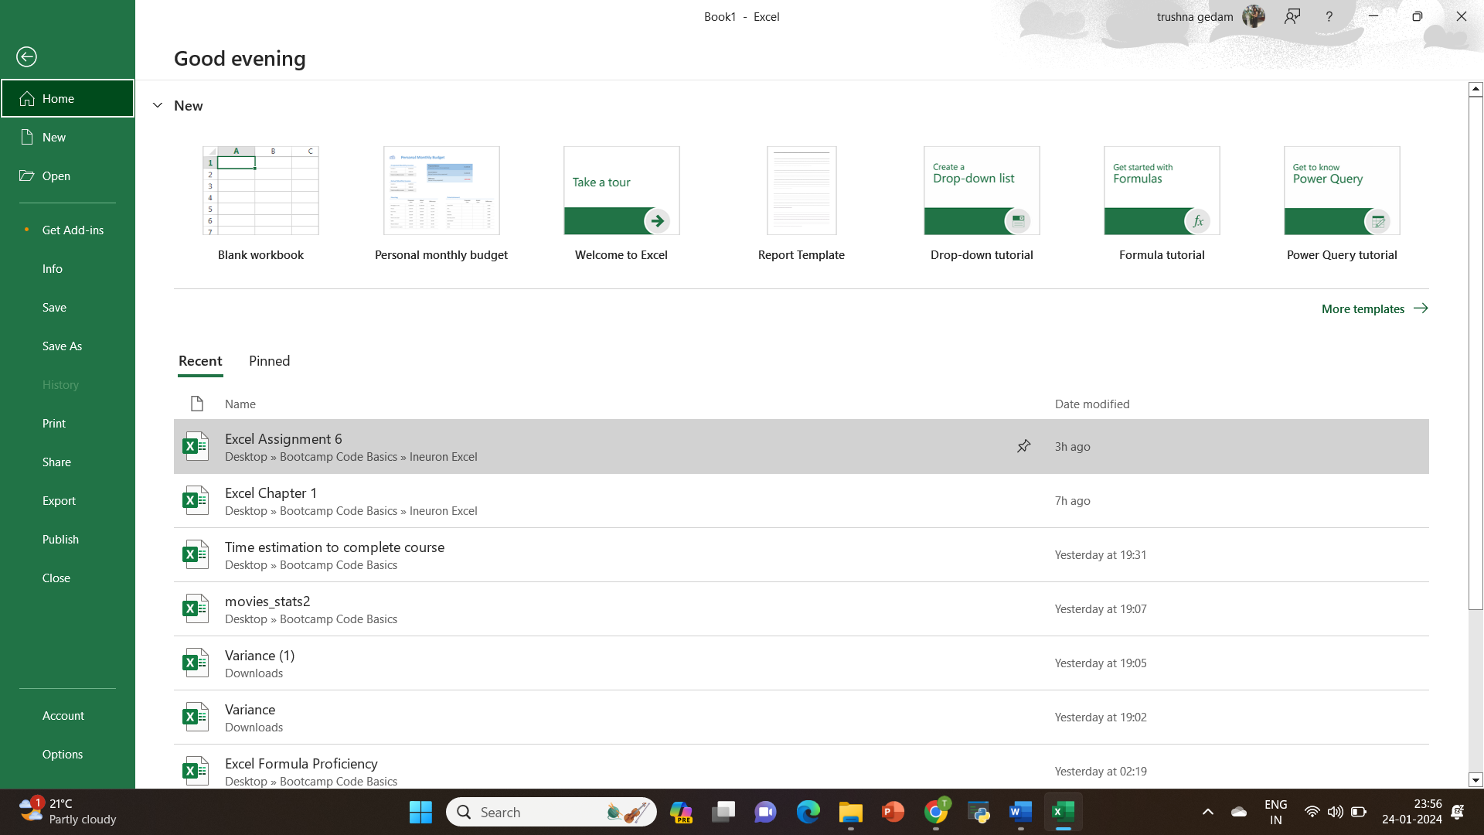

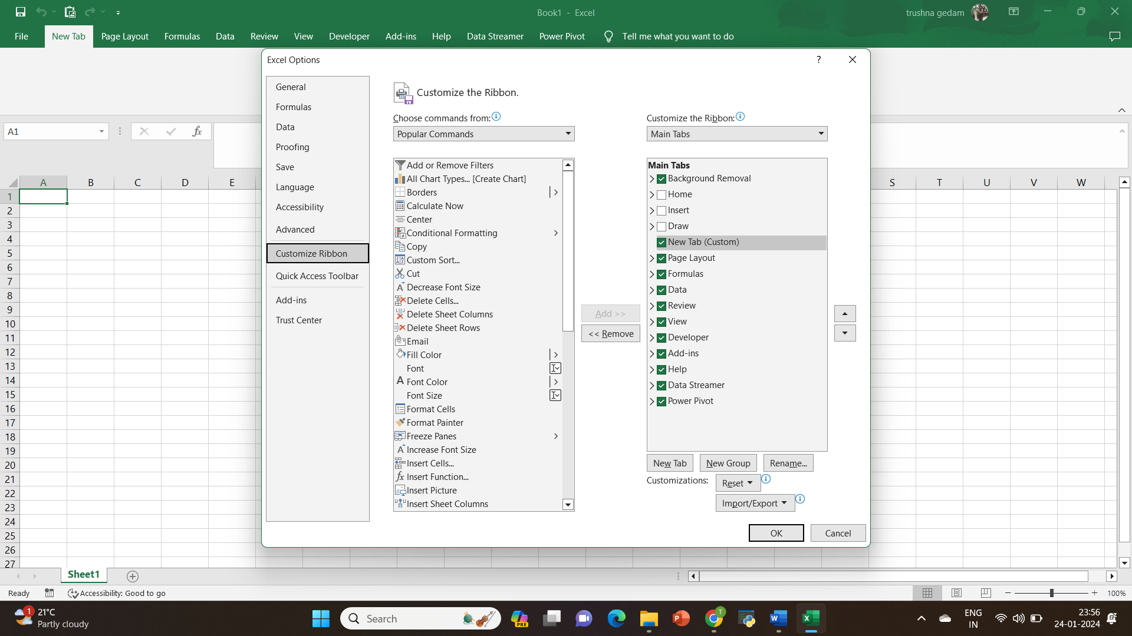

Under the “Main Tabs” section, click on “New tab” to create a New tab on the ribbon.

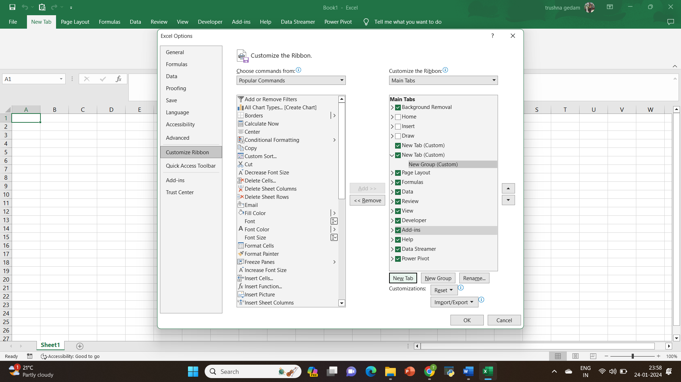

Select the newly created tab on the right side and Click the "Rename" button to give your new tab a meaningful name

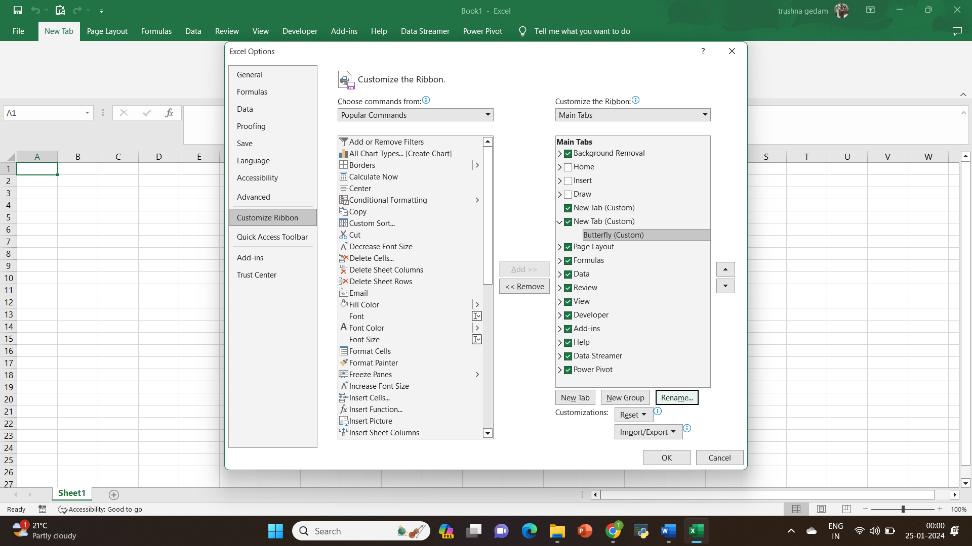

With the new tab selected, click on "New Group" to add groups to the tab. You can add multiple groups

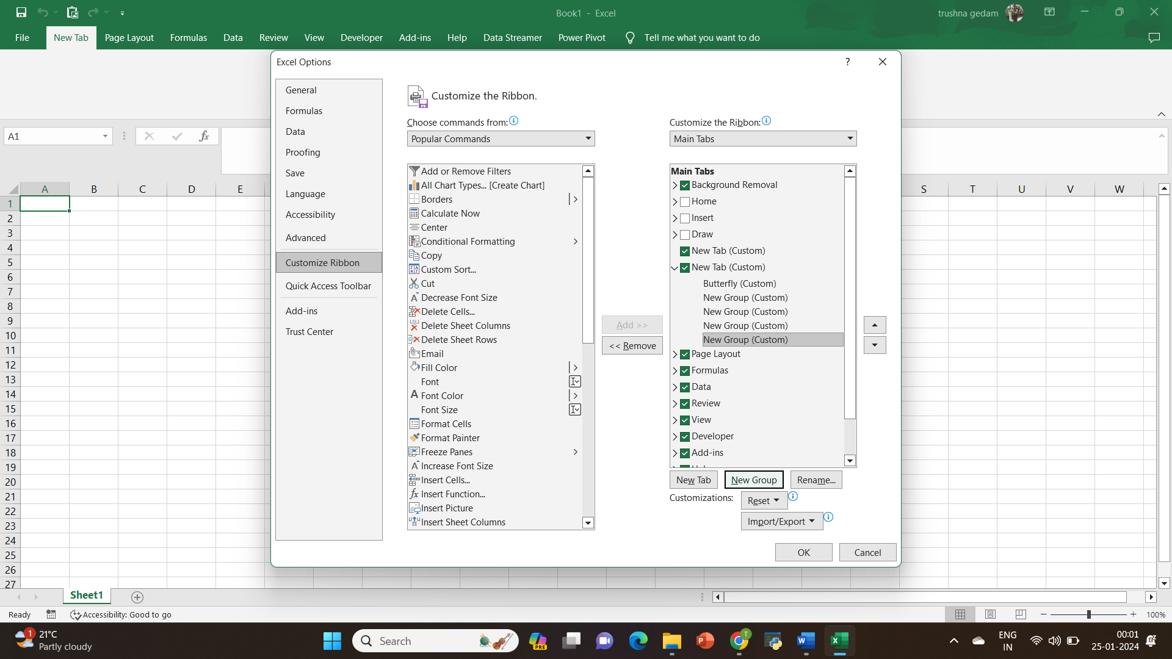

Select each group you created and click the "Rename" button to give them meaningful names related to the commands you'll add.

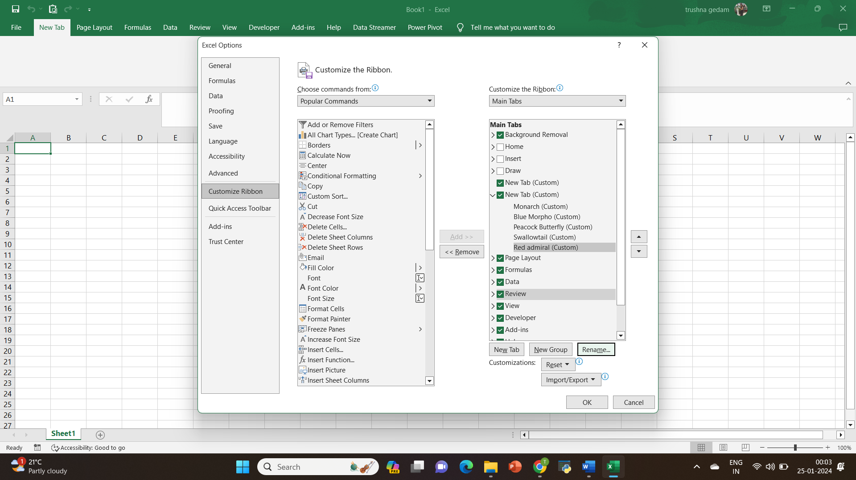

With a group selected, choose commands from the left side (Choose commands from) that you want to add to that group.

Click the command you want to add, and then click the "Add >>" button to add it to the group.

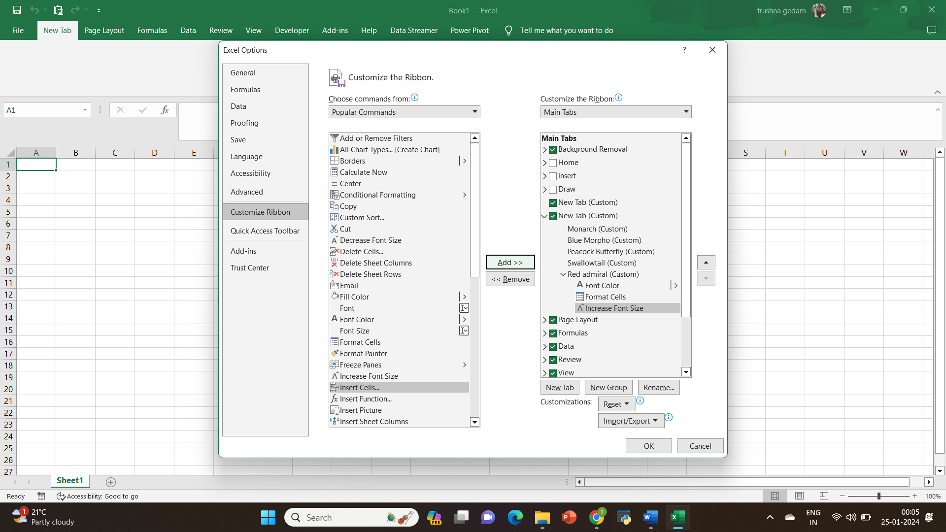

Use the "Up" and "Down" buttons to organize the order of commands within a group.

Once you've added groups and commands, click "OK" in the Excel Options dialog box to apply your changes.

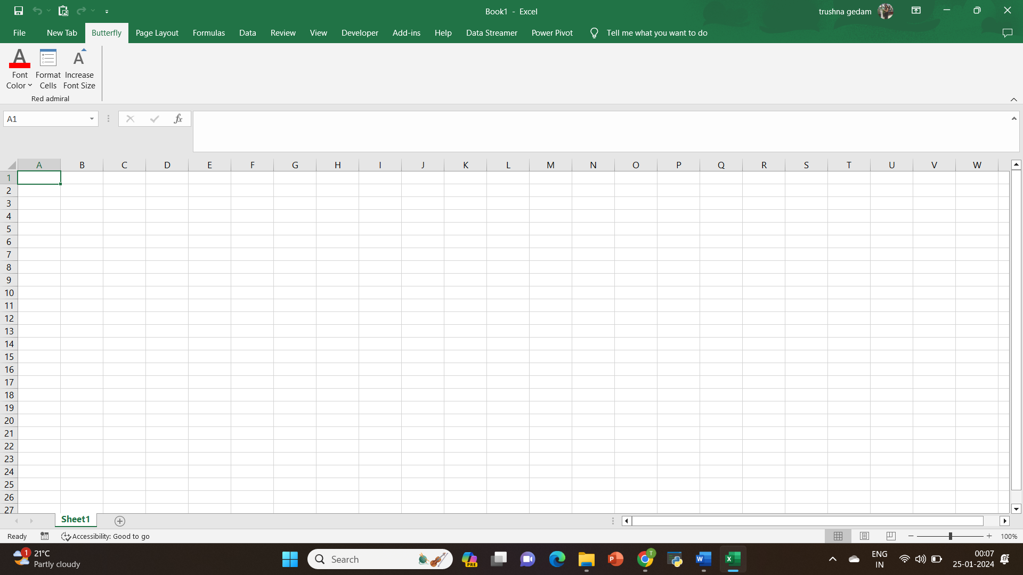

1. Make a list of different shortcut keys that are only connected to

formatting with their functions.

CONTROL + B: Applies bold font formatting to headers.

ALT + H + B + A: Applies borders to the cells.

ALT + H + B + T: Gives an outline border to the dataset.

ALT + H + O + W: Autofits column widths.

CONTROL + 1: Opens Format Cells dialog box

1. What distinguishes Excel from other analytical tools

* User-Friendly Interface
* Versatility
* Formulas and Functions
* Integration with Other Microsoft Office Applications
* PivotTables and Pivot Charts
* Scenario Manager and What-If Analysis
* Affordability
* Offline Accessibility

1. Create a table and add a custom header and footer to your table.  
   Go to Insert > Header or Footer.

Choose from a list of standard headers or footers, go to the list of Header or Footer options, and select the header or footer that you want.

When you're done, select Close Header and Footer or press Esc.

